**IOT LAB**

**Program No - 6**

**Program Title – PIR Sensor Program.**

**Aim – Demonstrate to show the working of PIR sensor.**

**Hardware Required-**

* Arduino Board
* Breadboard
* LED
* Resistor
* Wires
* PIR sensor

**Circuit Diagram –**

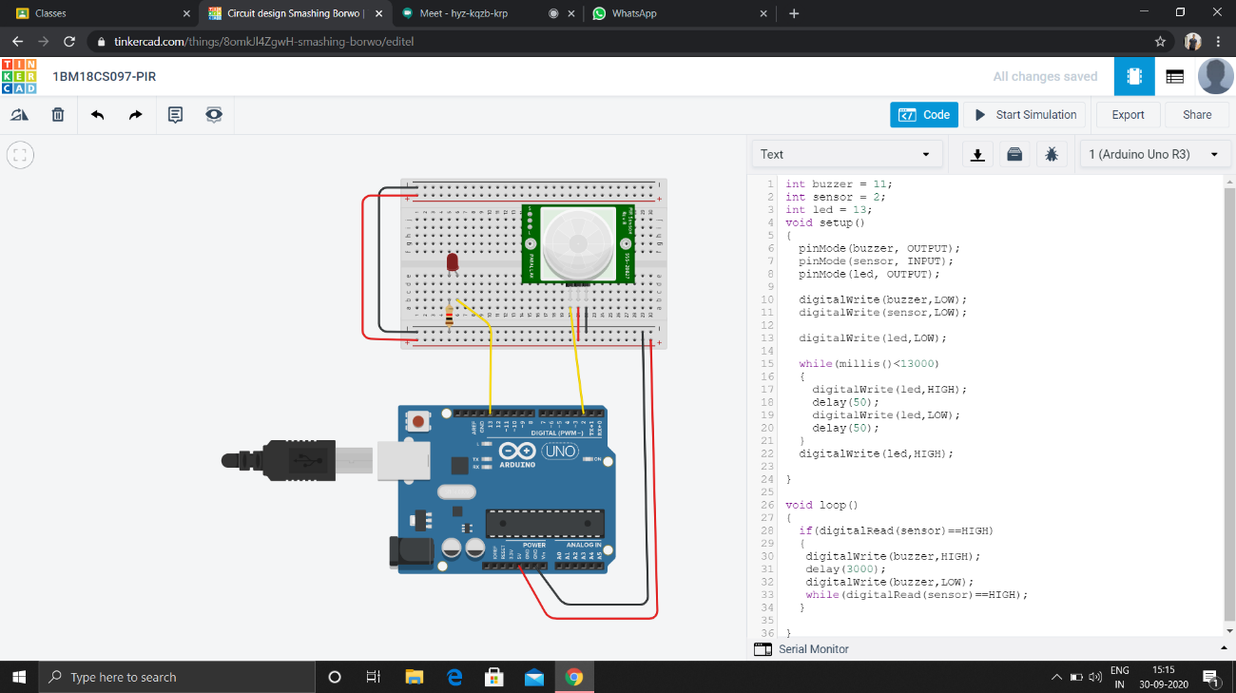

Code-

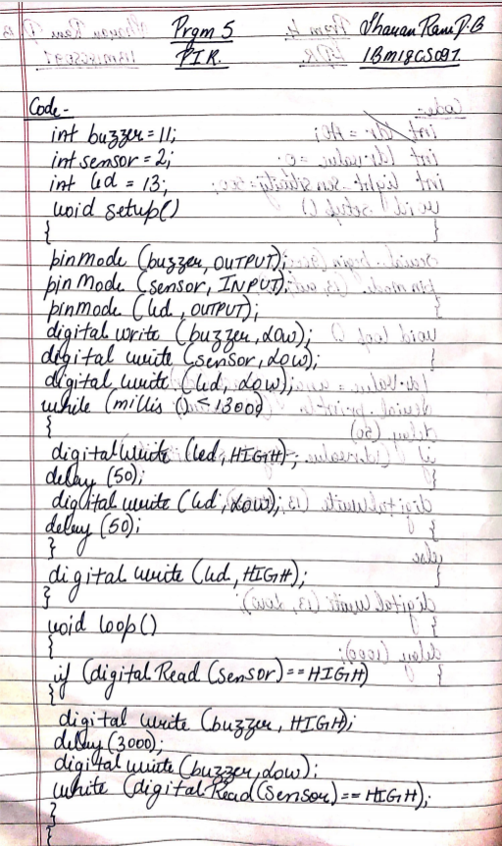

**Observation /Output –**

**We can see the glowing of led when the object is moved within the range of the sensors.**